VISVESVARAYA TECHNOLOGICAL UNIVERSITY BELAGAVI - 590018



Synopsis

On

StyleHarmony: Recommending Complementary Fashion Products using Compatibility Modeling

[18AIP77]

Submitted in partial fulfillment for the award of degree

BACHELOR OF ENGINEERING

in

Department of Artificial Intelligence and Machine Learning

by

ADITHI SHANKAR 1JT20AI003

KRUTHIKA R 1JT20AI018

SHRUTHI S K 1JT20AI042

SHWETHA S K 1JT20AI043

Under the Guidance of

Deepthi Das V

Assistant Professor

Department of AIML



Department of Artificial Intelligence and Machine Learning

**Jyothy Institute of Technology**

Tataguni, Off Kanakapura Road, Bangalore-560 082

**Academic Year 2023-2024**

**ABSTRACT**

The rapid transformation of global eCommerce, catalyzed by the COVID-19 pandemic, has reshaped consumer behavior and challenged traditional retail paradigms. In this evolving landscape, fashion retailers grapple with the daunting task of delivering personalized recommendations in a virtual environment devoid of face-to-face interactions. This project presents a groundbreaking approach to fashion recommendation systems, with a singular focus on suggesting complementary items to complete outfits. Through cutting-edge techniques in image embedding and compatibility modeling, our system endeavors to redefine the virtual shopping experience, offering tailored solutions that transcend the limitations of conventional eCommerce platforms.

**TABLE OF CONTENTS**

**ABSTRACT**

**TABLE OF CONTENTS**

1. **INTRODUCTION**
2. **PROBLEM STATEMENT**
3. **OBJECTIVES**
4. **HARDWARE AND SOFTWARE REQUIREMENTS**
5. **PROPOSED METHODOLOGY**
6. **REFERENCES**

**1. INTRODUCTION**

The global eCommerce landscape has undergone a seismic shift, propelled by the unprecedented circumstances of the COVID-19 pandemic, which has not only redefined consumer habits but also revolutionized the retail industry. The rapid surge in online spending, exemplified by a staggering 77% year-over-year increase in total online expenditures to $82.5 billion in May 2020, has accelerated the digital transformation of retail by decades. This paradigm shift presents a formidable challenge for fashion retailers who find themselves navigating the intricate realm of virtual commerce, attempting to captivate customers without the tangible and personalized interactions inherent in physical stores.

In this new era of digital retail, the traditional dynamics of customer engagement have evolved, compelling retailers to explore innovative strategies to understand and cater to their customers' preferences. Fashion retailers, in particular, face the daunting task of not just selling individual items but curating entire outfits without the luxury of observing customers in person. The absence of direct visual cues and the limited availability of customer data, consisting primarily of transaction histories and preferences, intensify the difficulty of providing meaningful and personalized recommendations.

Our project aims to address this fundamental challenge by honing in on the nuanced art of suggesting complementary items to complete outfits. By delving into the realm of compatibility modeling, our system seeks to empower retailers to enhance the virtual shopping experience, providing customers with curated selections that harmonize seamlessly. Importantly, our approach distinguishes itself by mitigating the reliance on extensive historical customer data, thereby serving as a beacon for the future of eCommerce. As we traverse this uncharted territory, our project contributes a unique and tailored solution to the evolving dynamics of digital retail, offering a glimpse into the potential of personalized and data-efficient virtual shopping.

1. **PROBLEM STATEMENT**

In today's fast-paced fashion industry, consumers often struggle to assemble cohesive and stylish outfits due to the overwhelming variety of available options. Moreover, they frequently face challenges in identifying complementary fashion products that harmonize well together. The goal of this project is to develop a model that recommends complementary products based on a given query product image. For instance, if the query product is a pair of leather pants, the model should predict suitable blouses or shoes to complement it. The challenge lies in training a compatibility model using the Polyvore dataset by Eileen et al., which contains diverse fashion items.

**3. OBJECTIVES**

1. **Adapt to Online Shopping Boom:** Make sure our product recommendation system works well with the increased number of people shopping online, especially since COVID-19 has pushed more people to buy things on the internet.
2. **Use the Increase in Online Spending:** Take advantage of the fact that people are spending a lot more money online. Adjust our system to match the growing demand for personalized and smart product suggestions.
3. **Help Fashion Stores Sell Better:** Understand that fashion stores face challenges in selling clothes when they don't know much about their customers. Our system should help these stores better understand what customers like.
4. **Reduce the Risk of Losing Customers:** Design our system to prevent customers from leaving a store's website because they can't find the right products. We want to make sure our suggestions are so good that customers stay.
5. **Deal with Limited Customer Information:** Recognize that stores often have limited information about what customers buy and like. Our system should help stores recommend products even with this limited information.
6. **Improve Product Visibility:** Ensure that our system helps products get noticed by customers, reducing the chance that customers leave because they can't find interesting things to buy.
7. **Make Recommendations More Accurate:** Fine-tune our system to make sure it suggests products more accurately, even when there's not much information available about what customers like.
8. **Boost Customer Loyalty:** Focus on using our system to keep customers coming back. We want to create a personalized and enjoyable shopping experience so that customers become loyal to the store.
9. **HARDWARE AND SOFTWARE REQUIREMENTS**

Hardware Requirements:

For the hardware requirement, we need:

1. Computer: We need a computer or laptop with sufficient processing power, memory, and storage to comfortably run a virtualization software like VirtualBox or VMware Workstation.
2. Memory (RAM): A minimum of 4 GB of RAM is recommended, but having 8 GB or more is preferable to run virtual machines smoothly.
3. Processor: A multi-core processor with support for hardware virtualization is essential for running virtual machines effectively.
4. Internet Connection: An internet connection is needed for downloading software, datasets, updates, and resources during your model building.

Software Requirements:

For the software requirement, we need:

1. Python (version 3.x): Essential for executing Python scripts and managing dependencies.
2. PyTorch: Deep learning library utilized for constructing and training neural networks.
3. Torchvision: A PyTorch extension handling image data and transformations.
4. NumPy: Fundamental package supporting scientific computing operations in Python.
5. os: Python module enabling interaction with the operating system, used for creating directories.
6. sys: Python module managing system-specific parameters and functions, employed for adding a specific path.
7. tqdm: Python module offering a user-friendly progress bar for loops and iterations.
8. pickle: Python module facilitating the serialization and deserialization of Python objects, applied for saving and loading features.

**5. PROPOSED METHODOLOGY**

**6. REFERENCES**

[1] A. Karpathy”Backpropagation, Intuitions” from Stanford’s CS231n, http://cs231n.github.io/optimization-2/, 2015.

[2] K. Simonyan, A. Zisserman ”Very Deep Convolutional Networks for Large-Scale Image Recognition” in ICLR 2015

[3] S. Zagoruyko, N. Komodakis ”Learning to Compare Image Patches via Convolutional Neural Networks” CVPR 2015, arXiv:1504.03641v1

[4] E. zgndz, T. entrk, and M. E. Karslgil, Off-line signature verification and recognition by support vector machine, in European signal processing conference, EUSIPCO, 2005.

[5] E. J. Justino, A. El Yacoubi, F. Bortolozzi, and R. Sabourin, An off-line signature verification system using HMM and graphometric features, in Fourth IAPR International Workshop on Document Analysis Systems (DAS), Rio de. Citeseer, 2000, pp. 211222.

[6] Yeung, D.-Y., Chang, H., Xiong, Y., George, S.E., Kashi, R.S., Matsumoto, T., Rigoll, G.: SVC2004:”First International Signature Verification Competition” in ICBA 2004. LNCS, vol. 3072, pp. 16-22. Springer, Heidelberg.

[7] Bailing Zhang. Off-line signature verification and identification by pyramid histogram of oriented gradients. International Journal of Intelligent Computing and Cybernetics, 3(4):611–630, 2010.

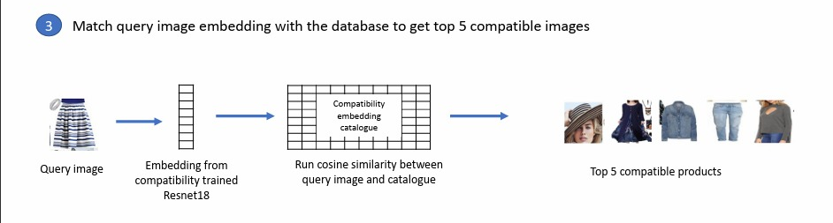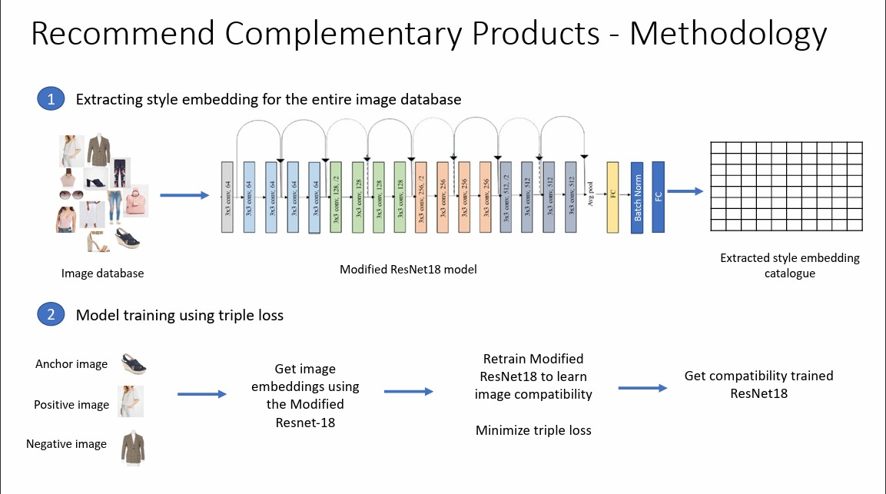

**Methodology Steps**

1. **Style Embedding Extraction for the Entire Image Database**:

* We begin by extracting style embeddings from the entire image database. To achieve this, we employ a **Modified ResNet18 model**. This model processes each image in the database and generates style embeddings.
* These style embeddings serve as compact representations of the visual style of each product. We catalog them for efficient retrieval during the recommendation process.

1. **Model Training Using Triple Loss**:
   * Our next step involves model training. Here’s how it unfolds:

* **Anchor Images**: We select an anchor image, which serves as a reference point.
* **Positive Images**: Positive images (similar in style to the anchor) are chosen.
* **Negative Images**: Negative images (dissimilar to the anchor) are also part of the training set.
* **Image Embeddings**: Each of these images undergoes processing via the Modified ResNet18 model to obtain their embeddings.
* **Retraining**: The model is retrained to learn image compatibility. It aims to minimize the **triple loss**, ensuring that similar images have embeddings that are closer in the embedding space.

1. **Matching Query Image Embedding with the Database**:

* When a user submits a query image, we extract its embedding using the same Modified ResNet18 model.
* We then compare this query image’s embedding with the cataloged embeddings from step one.
* **Cosine Similarity**: The similarity between the query image’s embedding and the cataloged embeddings is measured using cosine similarity.
* The result: We retrieve the **top 5 compatible images/products** from the database.
* These top recommendations align with the style of the original query image, providing users with complementary options.

**6. REFERENCES**

[1]https://www.forbes.com/sites/johnkoetsier/EFEF/F\/"E/covid-"d-accelerated-e-commercegrowth-X-to-\-years/?sh=\aXadc"f\FFf

[2] Z. Liu, P. Luo, S. Qiu, X. Wang and X. Tang, "DeepFashion: Powering Robust Clothes Recognition and Retrieval with Rich Annotations," EF"\ IEEE Conference on Computer Vision and Pattern Recognition (CVPR), EF"\, pp. "Fd\-""FX, doi: "F.""Fd/CVPR.EF"\."EX.

[3] Y. Shin, Y. Yeo, M. Sagong, S. Ji and S. Ko, "Deep Fashion Recommendation System with

Style Feature Decomposition," EF"d IEEE dth International Conference on Consumer Electronics (ICCE-Berlin), EF"d, pp. VF"-VFI, doi: "F.""Fd/ICCE-BerlinXNdXX.EF"d.Hd\\EEH.

[4] Eileen Li, Eric Kim, Andrew Zhai, Josh Beal, Kunlong Gu, "Bootstrapping Complete the Look at Pinterest", arXiv:EFF\."FNdE, June EFEF

[5] Mahamudul Hasan, Shibbir Ahmed, Md. Ariful Islam Malik, and Shabbir Ahmed, "A comprehensive approach towards user-based collaborative filtering recommender system," DOI:"F.""Fd/IWCI.EF"\.NH\FVIHDecember EF"\

[6] Greg Linden, Brent Smith, and Jeremy York, "Recommendations Item-to-Item Collaborative

Filtering," Amazon.com Industry Report EFFV

[7] Shuai Zheng, Fan Yang, M. Hadi Kiapour, Robinson Piramuthu, "ModaNet: A Large-Scale Street Fashion Dataset with Polygon Annotations," arXiv:"HFN.F"VdX, July EF"H

[8] Andreas Veit, Balazs Kovacs, Sean Bell, Julian McAuley, Kavita Bala, Serge Belongie, "Learning Visual Clothing Style with Heterogeneous Dyadic Co-occurrences," "IFd.FNXNVv" [cs.CV] EX Sep EF"I

[9] Wang-Cheng Kang, Eric Kim, Jure Leskovec, Charles Rosenberg, Julian McAuley, "Complete

the Look: Scene-based Complementary Product Recommendation," arXiv:"H"E.F"NXH, April EF"d

[10] Ruining He, Charles Packer, and Julian McAuley, "Learning Compatibility Across Categories for Heterogeneous Item Recommendation," arXiv:"\FV.FdXNV, September EF"\

[11] Qi Qian, Lei Shang, Baigui Sun, Juhua Hu, Hao Li, Rong Jin, "SoftTriple Loss: Deep Metric Learning Without Triplet Sampling," arXiv:"dFd.FIEVIvE [cs.CV] "I Apr EFEF

[12] Tong He, Yang Hu, "FashionNet: Personalized Outfit Recommendation with Deep Neural Network," arXiv:"H"F.FEXXV, October EF"H

[13] Chakraborty, S.; Hoque, M.S.; Rahman Jeem, N.; Biswas, M.C.; Bardhan, D.; Lobaton, E., "Fashion Recommendation Systems, Models and Methods: A Review," Informatics EFE", H, Xd. https://doi.org/"F.VVdF/informaticsHFVFFXd